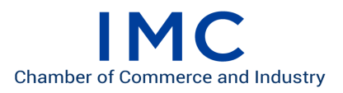
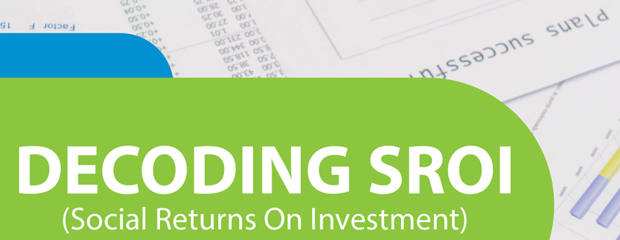

Date: OCTOBER 17, 2019 Time: 10.00 Am -4.00pm
The CSR committee of IMC Chamber of Commerce and Industry and S.P Jain Institute of Management and Research has jointly organized the captioned seminar.

Overview
As India completes 5 years of 2% mandatory CSR by India Inc, most reports can be summed up to a definite movement from apprehension, skepticism to narrowing the number of projects undertaken, strengthening partnership with implementing agencies and most importantly focus on measuring impact.

Social Return on Investment (SRoI) is a framework for measuring “value creation” done by the social initiatives. SRoI measures important changes relevant to stakeholders, moving from qualitative to measurable quantitative outcomes and outputs “that matter” for the social change. It helps government, CSR organisations in evaluating the projects being implemented by measuring social, environmental and economic outcomes using monetary values. It helps organisations in evaluating impacts of past projects, estimating impacts for proposed projects, redefining strategy, strengthening implementation and monitoring systems.

Considering the importance of SRoI in present time and years to come, IMC and SPJIMR is attempting to inform, sensitize and prepare the CSR/HR teams of India for creating greater social impact.

Objectives:
- Facilitate understanding and discussion amongst participating CSR professionals on SRoI
- How SROI can help in maximizing the social value and direct resources for it
- Help define process and identify people who will implement
- To understand SRoI reporting for internal and external stakeholders

Who Can Participate
- CSR teams of India Inc & Corporate Foundation Team
- NGOs/CSOs as implementing agencies
- CSR Consultants/ Practitioners
- HR professionals/ Consultants
- Senior Management Officers
- Any other interested

Benefits to Participants
- The participants would understand the latest measurement tool(SRoI) for evaluating their own projects.
- SRoIs would help in creating comparable standards between project over a period.
- Learning from real life examples, one can apply the tool in their own setting.

PROGRAM SCHEDULE
9.30 am | REGISTRATION
10:00 am | Welcome Address  Mr. Ashish Vaid, President, IMC Chamber of Commerce and Industry
10:10 am | Theme Address  Mr. Ramesh Daswani, Chairman CSR Committee, IMC and Dr. Vivek Mendonsa, Convener
10:20 am | Message by Dr. Ranjan Banerjee, Dean, SPJIMR
10:30 am | Tea Break
11:00 am | Session 1:  - Prof. Rukaiya Joshi, Professor- Chairperson - Centre for Education in Social Sector (CEdSS) SPJMIR  - Mr. Jignesh Thakkar, Associate Director - CSR & Sustainability at KPMG
1:00 am | Lunch
2:00 pm | Session 2:  Panel Discussion: Perspectives and Experiences on SRoI – A way Forward  Moderator: Mr. Anjani Agrawal, Chairman, Thinkthrough Consulting  - Mr. Srinath Komarina, President, Yes Bank  - Mr. Ashwini Saxena, COO, JSW Foundation  - Ms. Afreen Siddiqui, UNDP  - Mr. Saurabh Singh, President, ICICI Foundation  - Ms. Sushant Verma, Asia Regional Director, Trickle Up
3:30 pm | Vote of Thanks – Mr. Tanil Kilachand, Co Chairman, CSR Committee IMC
*invited
REGISTRATION
Kindly use the following websites for online registration: www.imcnet.org. The fees for the seminar are
IMC Members: Rs. 3,000/- per participant (inclusive of GST)
Non IMC Members: Rs. 3,500/- per participant (inclusive of GST)
Students: Rs 1500/- per participant (inclusive of GST)
For further details please contact Ms. Anita Naik at anita.naik@imcnet.org or
Phone: Tel.: 022 71226686
We cordially invite you to attend this Seminar. Registrations are mandatory due to limited number of seats and are accepted on a first-cum-first-serve basis.

We look forward to your participation.

Ajit Mangrulkar
Director General,
IMC Chamber of Commerce and Industry.

